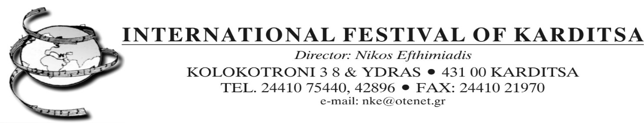

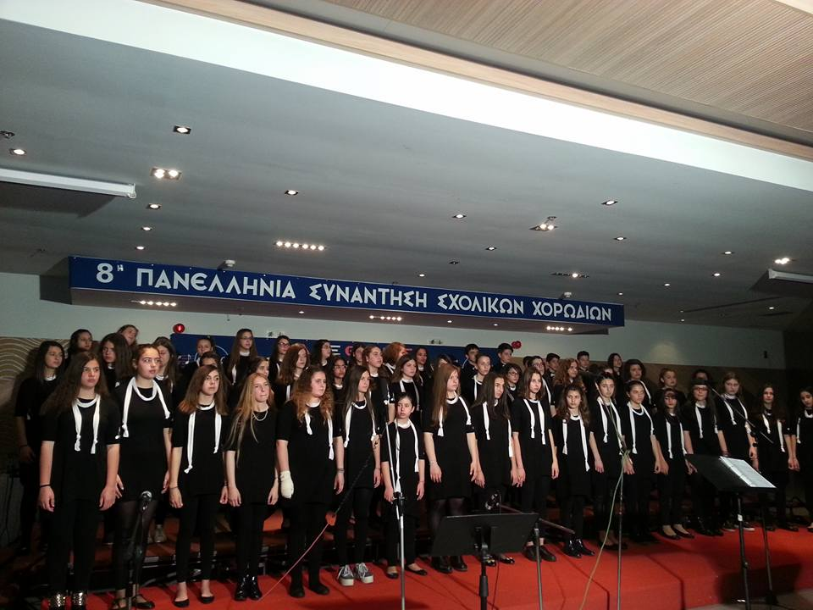

"16th INTERNATIONAL FESTIVAL OF SCHOOL ORCHESTRAS AND CHOIRS (KARDITSA-GREECE)"

From 28th of March – 7th of April 2024 the 16th INTERNATIONAL FESTIVAL FOR SCHOOL ORCHESTRAS AND CHOIRS will take place in Karditsa, Mouzaki, Byzantine Castle of Fanari and Lake Nikolaos Plastiras (Greece) and the 42nd International Festival of Karditsa. The Festival is held under the aegis of the Greek Ministry of Education and the Greek Ministry of Culture.

THE INTERNATIONAL FESTIVAL OF SCHOOL ORCHESTRAS AND CHOIRS of KARDITSA is an important artistic event in Greece due to the numerous and diversified participation from all over the world (Italy, France, Spain, Albania etc.)
The 16th International Meeting of School Orchestras and Choirs is dedicated to the Czech composer Bedřich Smetana for the 200th anniversary of his birth (1824-1884), to Giacomo Puccini (1858-1924) for the one hundred (100) anniversary of his death, to Luigi Nono (1924-1990) for the hundred (100) years since his birth and to the Austrian composer Anton Bruckner (1824-1896) mor the two hundred (200) years since his birth.
It is also dedicated to the leading Choral work "Ode of Joy" from Beethoven's 9th Symphony, an immortal work of the great Composer, written in 1824 and this year marks two hundred (200) years since the composition of the 9th.

The philosophy of the Festival points not only to an artistic approach but also to a musical-pedagogical and social approach. The purpose of the Festival is to compare the different cultures and ethnic groups in the world and specifically to promote the choral, instrumental and orchestral musical culture of the various participating schools; furthermore, the ultimate aim is to make the ancient and contemporary world musical tradition known and thus bring to the fore of the participating public.

So far, important choirs and school orchestras from Greece and abroad have participated in the International Festival of Orchestras and School Choirs of Karditsa.

It has become the most important Festival in Greece and one of the most important in Europe and in the world due to the great participation of School Orchestras and Choirs. More than 5000 student musicians, instrumentalists and vocalists, singers, artists participated in this event.
School Orchestras and Choirs of all kinds (mixed choirs and orchestras, male, female and children's voices), as well as groups of soloists and chamber school choirs and orchestras can participate in the Festival.

The repertoire-performance program is free to choose, (but preferable) if the Orchestras and Choirs of the Schools could perform:
• one (1) piece from ancient Greece,
• one (1) Religious piece,
• one (1) polyphonic piece from the 15th century (1400 inhab.-1500 about.),
• one (1) piece from the 16th century (1500 inhab.-1650 about.),
• one (1) piece of contemporary music
• one (1) song a piece of popular music.

The Orchestras and School Choirs can also be accompanied by dancers and traditional costumes representative of the region-country of origin.

The event takes place as part of the 41st International Festival of Karditsa, one of the greatest cultural and musical events that is under the the artistic direction of Dr. Nikos Efthimiadis.
The 16th INTERNATIONAL FESTIVAL OF SCHOOL ORCHESTRAS AND CHOIRS of the 42nd International Festival of Karditsa includes many other artistic events which are: evenings of Opera, Symphonic Music, religious music at the Byzantine Castle of Fanari, at Lake Nikolaos Plastiras, with performances by groups of music, painting exhibitions etc.

This important event is organized by the Karditsa International Festival in collaboration with the Conservatory of Karditsa - “Nikos Efthimiadis”. The event is supported by:
• The Panhellenic Federation of Choirs and Choir Directors,
• the Municipality of Karditsa,
• the Municipality of Mouzaki,
• the Region of Thessalia
• and finally is held under the aegis of the Greek Ministry of Education and the Greek Ministry of Culture.
School groups (orchestras and choirs) can participate in the event regardless of the type of choir-orchestra, with a maximum of 50 members. Participants can choose their own repertoire (the maximum time available for the performance is 30 minutes).

The participating orchestras and school choirs are responsible for their own expenses (travelling, accommodation, meals). The participation fee is € 20.00 for each student / participant.
The best orchestras and choirs of the Karditsa Festival will be rewarded with participation in International Festivals and Competitions in different countries.

The deadline for submitting the application form is the 31st of January 2024.

For information, please contact the Secretary of the International Festival of Karditsa, Kolokotroni 38 & Ydras, 43131 KARDITSA Greece, Tel: +0030/2441075440, +0030/2441021369
Mobile: +0030/6944442532 (Music Director: Dr. Nikos Efthimiadis). Email: nke@otenet.
http://festivalofkarditsa.blogspot.gr/,
Facebook: https://www.facebook.com/pages/International-Festival-Of-Karditsa/430401250405622?ref=hl

PS: For information on excursions contact the Festival secretariat.

Places to visit:
• Meteora (famous and unique complex of monasteries located on very high rocks, about 50 km from Karditsa);
• Delphi (renowned archaeological place where the Oracle and the Temple of Apollo are located, about 150 km from Karditsa)
• Sea (about 90 Km),
• Temple of Leonidas in Thermopylae (100 Km. from Karditsa).
• Royal Burial Cluster of Phillip II (the father of Alexander the Great 120Km), Vergina

